**SQL Queries**

**Query 1**

**What are the average ratings for guests and hosts, and how do they compare to each other?**

SELECT 'Average Guest Rating' AS RatingType, AVG(GuestRating) AS AverageRating

FROM GuestReviews

UNION

SELECT 'Average Host Rating' AS RatingType, AVG(HostRating) AS AverageRating

FROM HostReviews;

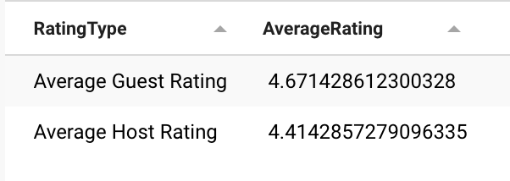**’**

**Average Ratings for Guests and Hosts:** This query is useful for assessing the overall performance and satisfaction levels of both guests and hosts. Utilizing the GuestReviews and HostReviews entities aligns with your goal of ensuring transparency and trust**.**

**Query 2**

**What are the properties with a rating greater than 4.0 that have been reserved by guests, and how are these properties categorized by room type and price per night?**

SELECT Guest_UserID, PropertyID, RoomType, Rating, PricePerNight

FROM Property

NATURAL LEFT JOIN Reservation

NATURAL LEFT JOIN Guests

WHERE Rating > 4.0

ORDER BY Rating DESC;

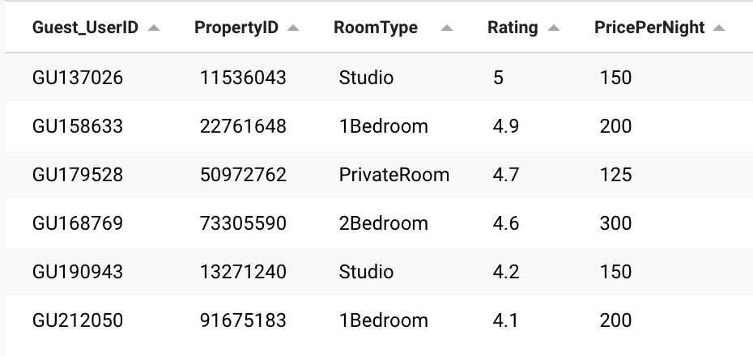

**Highly Rated Properties:** This query identifies properties with ratings greater than 4.0 and categorizes them according to room type and price per night. This is useful for guests seeking high-quality accommodations and aligns with your goal of making property recommendations based on guest preferences and feedback.

**Query 3**

**What are the total amounts spent and the durations of stay for each guest who has booked a property in Metroville, along with the street names of those properties?**

SELECT Guest_UserID, Street, TotalPrice AS AmountSpent,

DATEDIFF(EndDate, StartDate) AS DurationOfStay

FROM Reservation

NATURAL LEFT JOIN Property

WHERE City = 'Metroville'

ORDER BY Guest_UserID;

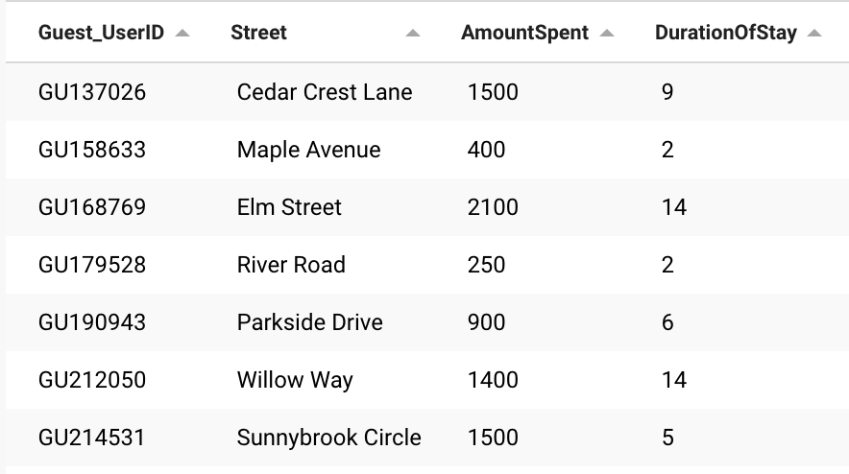

**Guest Spendings and Durations in Metroville:** This query is excellent for gaining insights into guest behavior in a specific city, Metroville. It provides information on the total amount spent, the duration of stay, and property location details. This aligns with your goal of gaining business insights and understanding user behavior.

**Query 4**

**What is the total amount of money spent by all guests on accommodations in Metroville?**

SELECT SUM(TotalPrice) AS TotalSpending

FROM Reservation

Natural Left JOIN Property

WHERE City = 'Metroville';

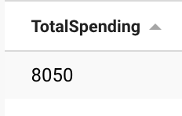

**Total Spendings in Metroville**: This query offers a consolidated view of the money spent by visitors in Metroville. It aligns with your objective of understanding market trends and the financial performance in specific areas.

**Query for Visualization**

**What are the total earnings of each host and the average loyalty points of guests who have stayed in their properties, and how do these earnings and guest loyalty points vary by host?**

SELECT Host_UserID, SUM(TotalPrice) AS HostEarnings,

Guest_UserID, AVG(LoyaltyPoints) AS AverageGuestLoyaltyPoints

FROM Hosts H

Natural left JOIN Property

Natural left JOIN Reservation

Natural left JOIN Guests

GROUP BY Host_UserID

ORDER BY HostEarnings DESC;

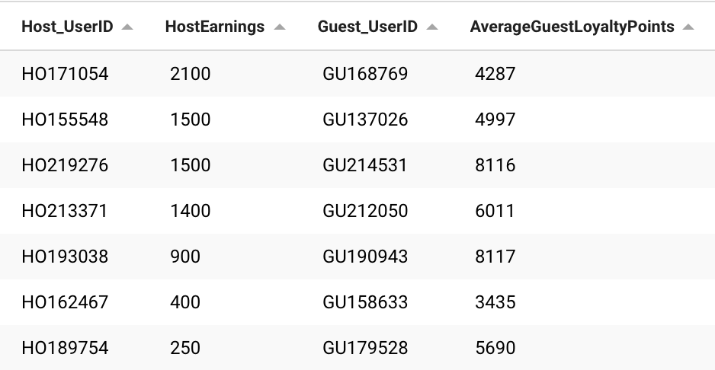

**Host Earnings and Guest Loyalty Points**: This critical query helps in understanding the financial performance of hosts and the engagement of guests through loyalty points. It directly supports your goals of rewarding top-performing hosts and encouraging guest loyalty.